**ASSIGNMENT-04**

**Question #1:**

A man wants to go for tour of different countries. He has 10000000 PKR initially, He decided to take a tour of France, England, Spain, Canada and Japan. He decided to divide this amount equally, i.e. 2000000 for each country tour. Write a Program to convert the divided amount (which is in Pakistani rupees) into Swiss franc, Pound Sterling, Spanish Euro, Canadian Dollar and Japanese Yen.

**Source Code:** 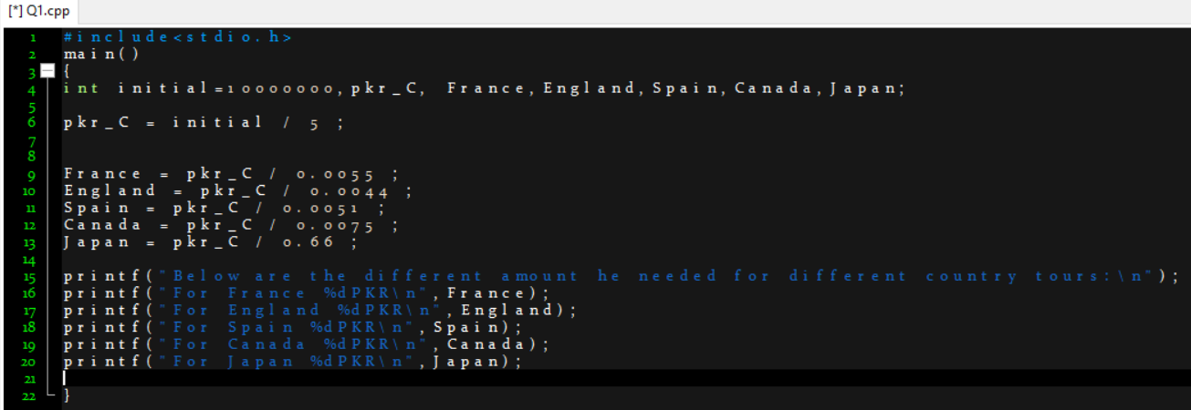

**Output:**

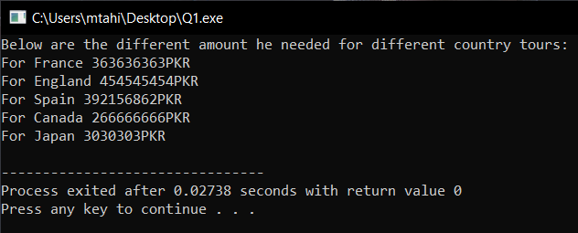

**Question #2:**

One of the jobs that Joe Roberts has been given at work is to order special paper for are port for a board meeting. The paper comes in reams of 500 sheets. He always makes five more copies than the number of people that will be there. Joe wants to know how many reams of paper he needs for a meeting. He can order only whole, not partial, reams. Assume the required number of pages will not equal an exact number of reams. Test your solution using scratch with the following data:

The report is 140 pages long.

There will be 25 people at the meeting.

**Source Code:**

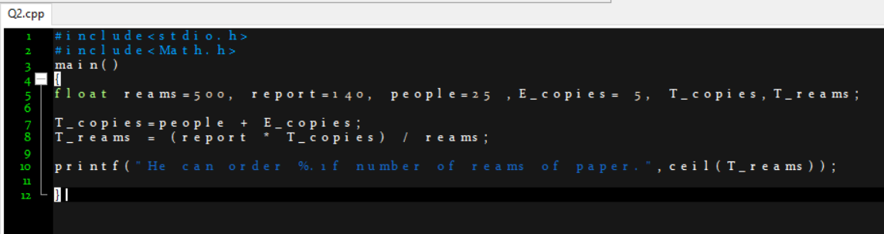

**Output:**

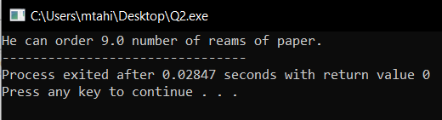

**Question #3:**

Explain the order of evaluation of the operators in each of the following statements, show the value of x after each statement is executed using the C program. Compare your computed answer with the answer shown after execution of C program.

a= 2, b=4, c=2

a) a + b / c + b % 2 * a - c

b) a++*(a/b*c) +b--

c) a++*(a/b*c) +--b

**Handwritten Code of A:**

**Source Code of A: Output:**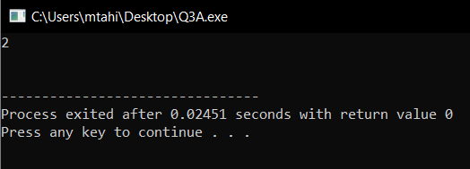

**Handwritten Code of B:**

**

**Handwritten Code of C:**

**

**Question #4:**

Write a C program that takes temperature in Celsius and converts it into Fahrenheit and Kelvin.

**Source Code:** 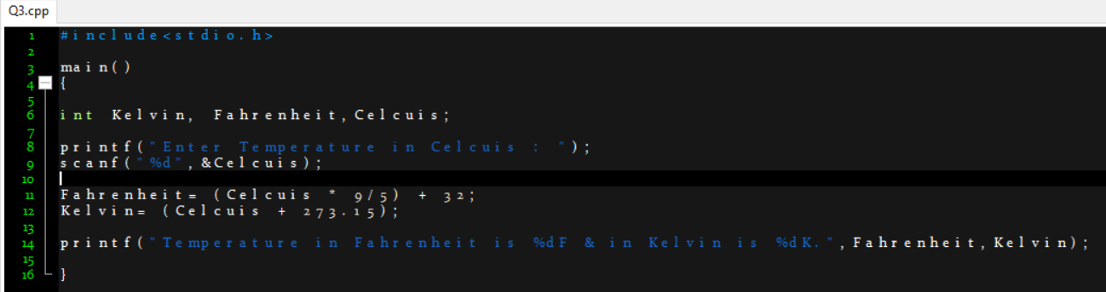

**Output:**

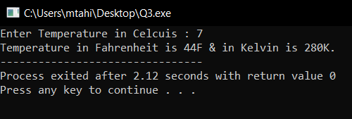

**Question #5:**

Write a C program that takes user year of birth as input and tell him/her his age (in years only) in 2021.

Sample output:

Enter your birth year: 1997

Your age in 2021 = 24 years

**Source Code:**

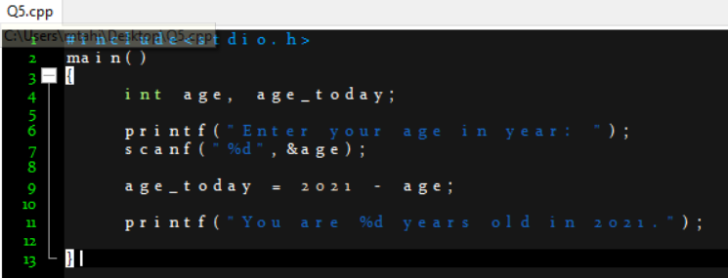

**Output:**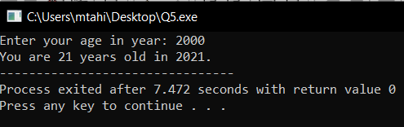

**Question #6:**

Write a C program to Find out distance, coordinates of midpoint using distance formula, derived from Pythagorean Theorem and value of X by Quadratic formula, as follows:

Distance = √((x2-x1) ^2 + (y2-y1) ^2)

Midpoint= ((x2+x1/2), (y2+y1/2))

x = −b±√b2−4ac / 2a Given (a≠0.)

**

**Output:**

**Question #7:**

Write c program that find the result of the following operations: you are allowed to initialize any values. Observe and write in comment how that operation produces results.

1. True OR False AND NOT True
2. “A” > “H”

**Source Code of A:**

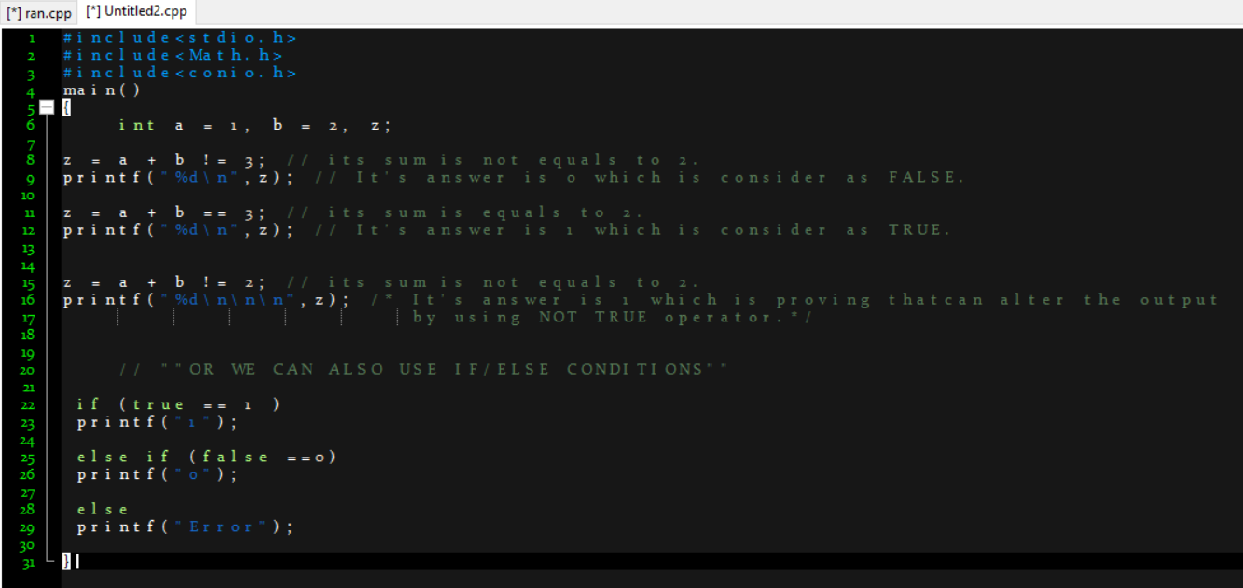

**Output:**

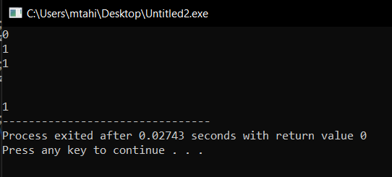

**Source Code of B:** 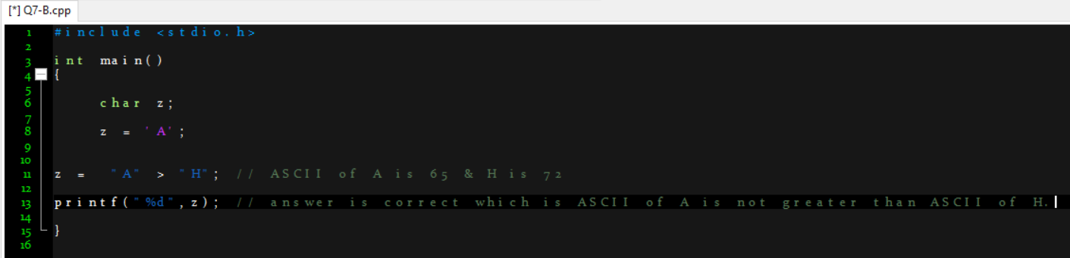

**Output:**

**Question #8:**

In a cricket match between England and New Zealand, England gave the target of 282 runs. In the first 10 overs of a cricket game, the run rate of New Zealand was only 3.2 runs. Write a C program to calculate the run rate in the remaining 40 overs to reach the target of 282 runs.

**Source Code:** 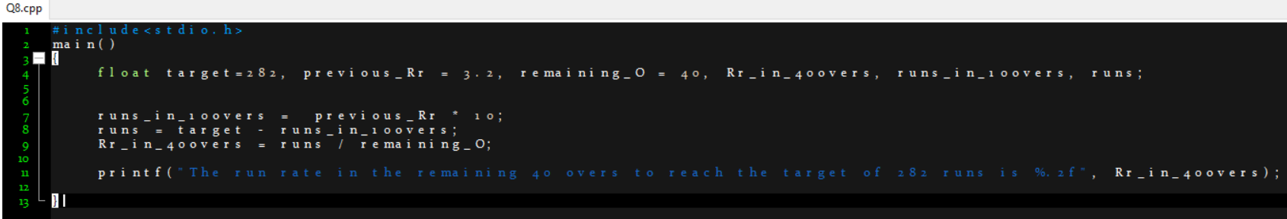

**Output:**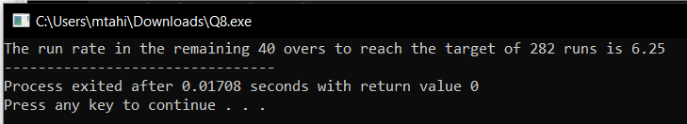

**Question #9:**

A shopkeeper sells watches in 45 rupees each. He purchased watches for Rs. 20 per piece. Write a C Program to calculate profit and profit percentage.

**Source Code:**

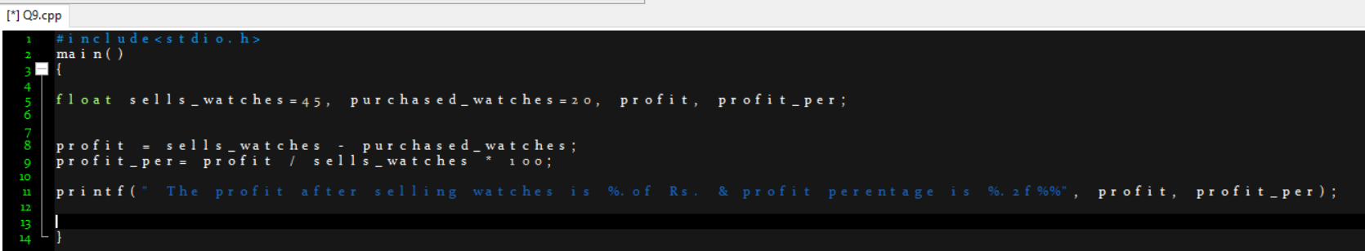

**Output:**

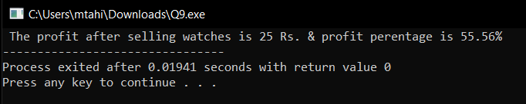

**Question #10:**

a) 600-meter-long distance was crossed by a man in 5 minutes. Construct a C Program to find out the speed in km per hour.

b) Calculate the hypogenous for a right-angle triangle in which user inputs base and perpendicular of a triangle. Use functions from Math.h library to calculate square.

**Source Code of A:** 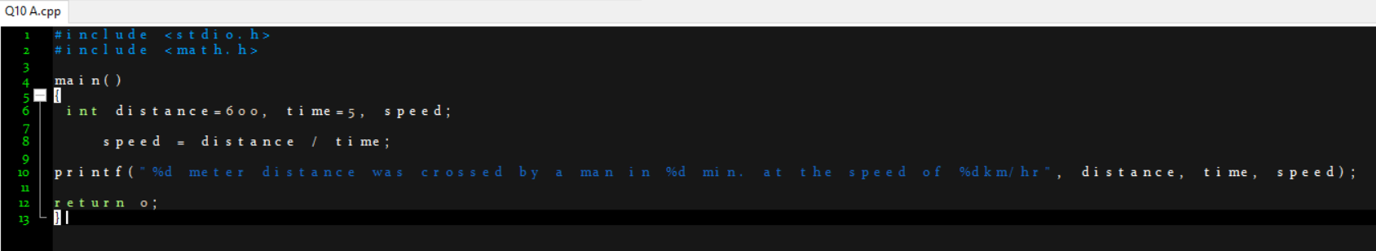

**Output:**

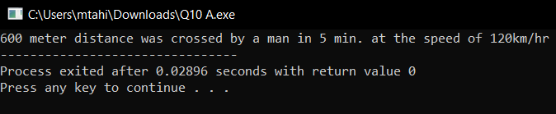

**Source Code of B:** 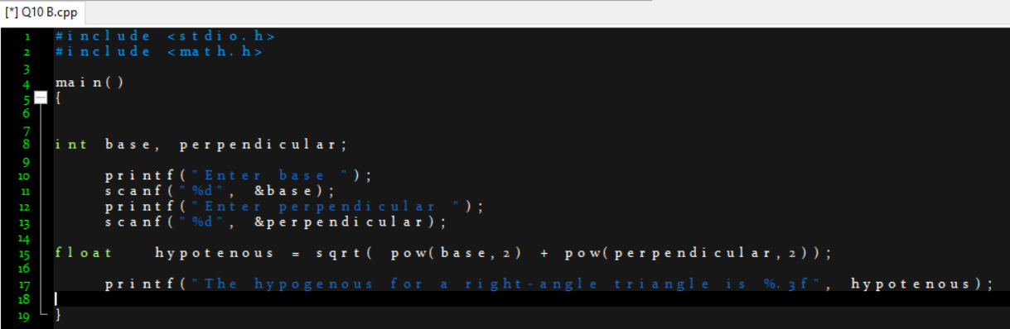

**Output:**

